**Selenium Lab**

**Lab1: Example (Basic Selenium IDE Flow)**

Goal: Understand the process of automation testing of a web application on Selenium IDE ∙ Learn to manage document spacing

**Output:**

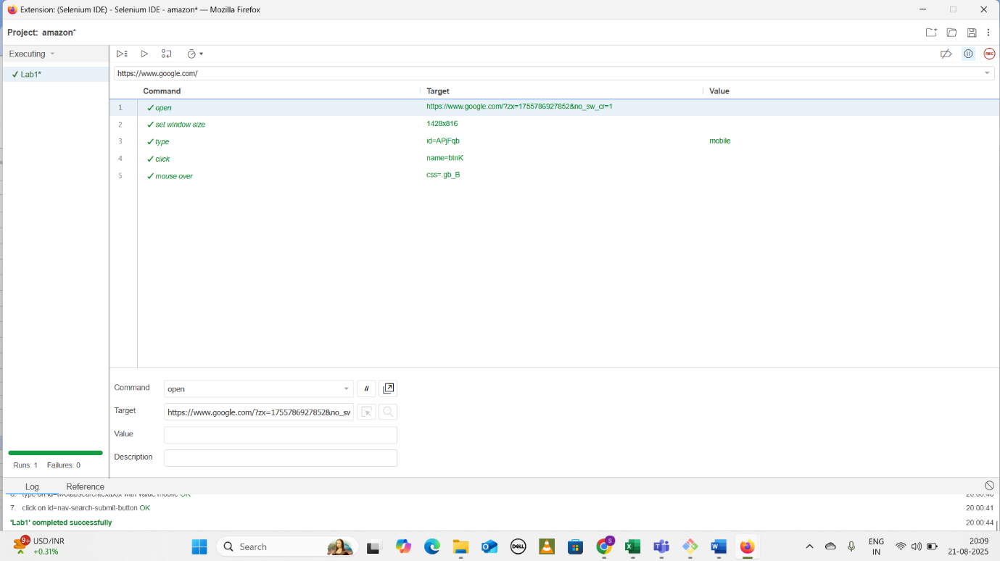

**Lab2: Learning Selenium IDE (Modifications)**

Goal: Understand the process of further modifications and validations in automation testing of a web application on Selenium IDE ∙ Learn to manage document spacing

Basic URL: <https://www.amazon.in/>

**Steps:**

Step1: Follow the steps from Lab 1

Step2: In order to add new command, go to the command where the new command needs to be added and then do right click , click on ‘Insert New Command’.

Step3: ‘Command’ dropdown provides options/ keywords to perform the operation

**Output:**

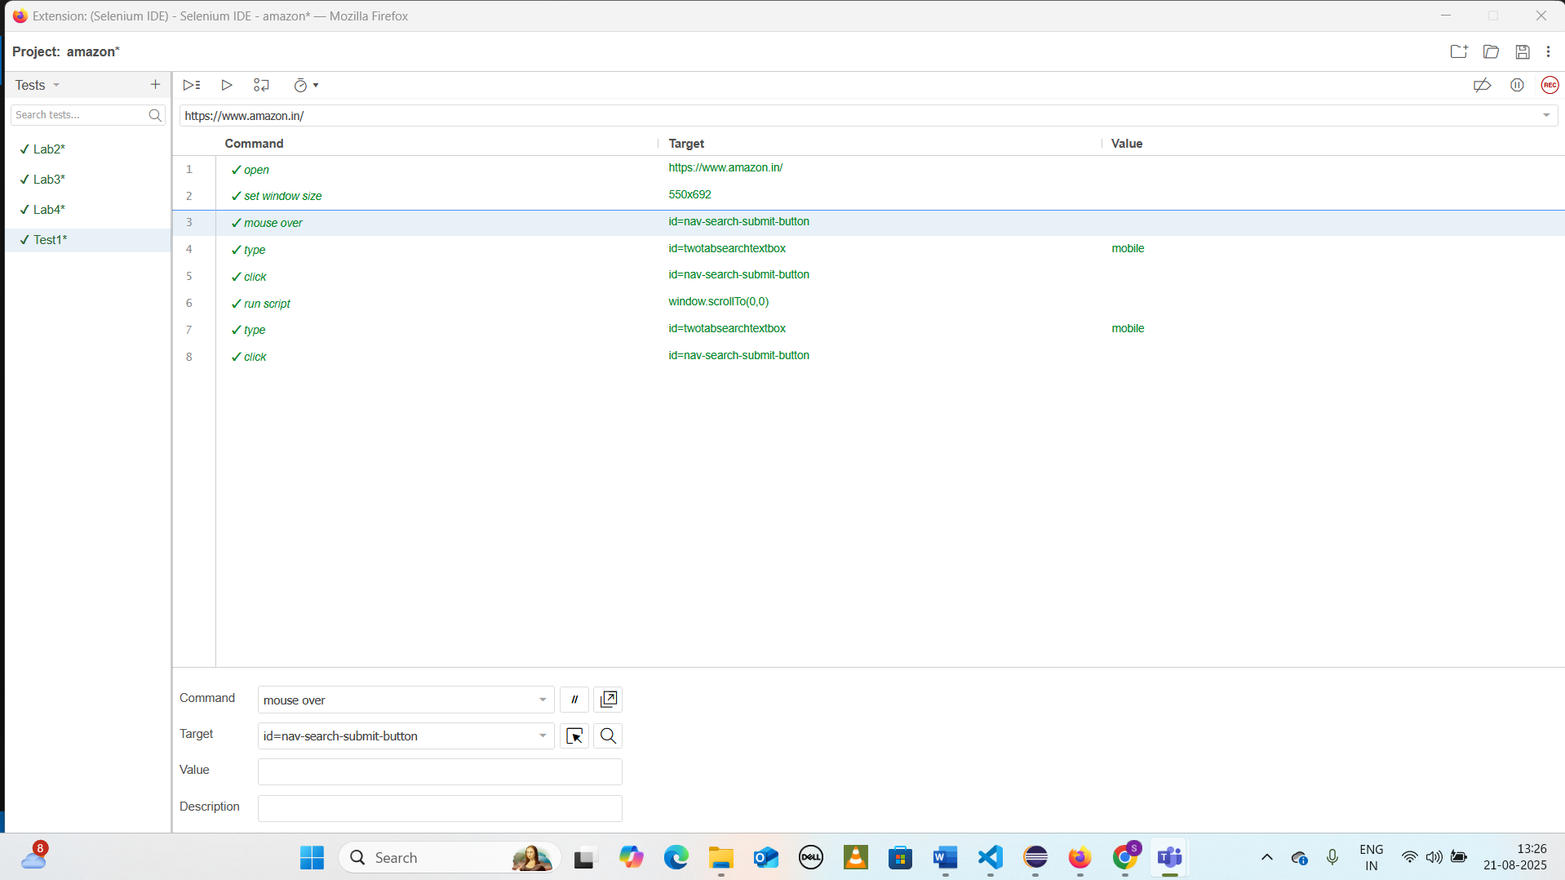

**Lab3: Learning Selenium IDE(Basic Flow)**

**Goal: Understand the basic process of automation testing of a web application in Selenium IDE ∙ Learn to manage document spacing**

**Steps:**

Step1: Open the URL on Firefox

Step2. Start recording on Selenium IDE

Step3. Go to 'Desktops' tab

Step4. Click on 'Mac'

Step5. Select 'Name(A-Z)' from the 'Sort By' dropdown

Step6. Click on 'Add to Cart' button

Step7. Stop the recording on Selenium IDE

Step8. Playback the whole test case

**Output:**

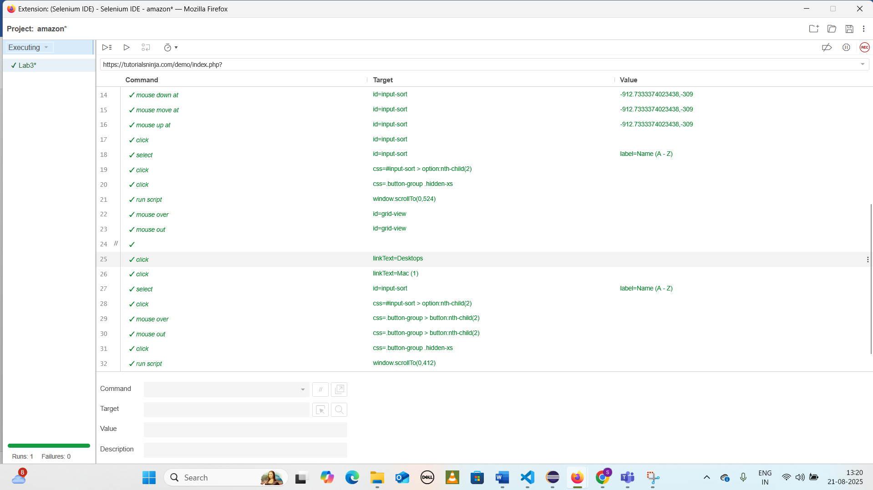

**Lab4: Learning Selenium IDE(Performing Validations)**

**Goal: Understand the process of automation testing of a web application ∙ Learn to manage document spacing**

**Steps:**

Step1**:**Open the URL on Firefox

Step2: Start recording on Selenium IDE

Step3: Verify title of the page

Step4:Go to 'Desktops' tab

Step5: Click on 'Mac'

Step6: Select 'Name(A-Z)' from the 'Sort By' dropdown

Step7: Click on 'Add to Cart' button

Step8: Enter ‘Mobile’ in ‘Search’ text box and click on ‘Search’ button

Step9: Wait for page to load

Step10. Clear the text from ‘Search Criteria’ text box

Step11. Click on ‘Search in product descriptions’ check box and click on ‘Search’ button

Step12. Stop the recording on Selenium IDE

Step13. Add the step after Step 5 where verify the 'Mac' heading

Step14. Change the value from ‘Mobile’ to ‘Monitors’

Step15. Save the test case

Step16. Playback the whole test case.

Step17. Playback set by step

Step18. Add the step after Click on 'Mac' where verify the 'Mac' heading

Step19. Save the test case

Step20. Export the test case as 'Java/JUnit/webDriver'

Step21. Run the whole Test case and check the 'Pass' Status

Step22. Create another test case with the same flow 23. Create the test suite for the above test cases

**Output:**

